Anusha, several remarks:
- When I used the real winch calibration, the deployed tether lengths were significantly less than we thought out in the Mojave.
- The boundary layer data we got is, as you already know, noisy. Given the passage of a front at the time we measured, this is not surprising. I don’t believe the noisiness is due to the sensor, but in fact reflects measurement data weather.
- Our measured data are roughly consistent with a boundary layer thickness of ~1200 ft, a velocity at the outer edge of the boundary layer of ~ 20 ft/sec, and a power law profile of ` 1/6. I don’t think it’s worthwhile to try to get a least squares fit….the data is noisy.
- The curve below shows how it plots. The gaps are an artifact of Excel’s plotting function. I suggest you hand fill them in with some straight lines.
- All this shows we’re on the right track. I’m encouraged
- Please send me your draft manuscript.

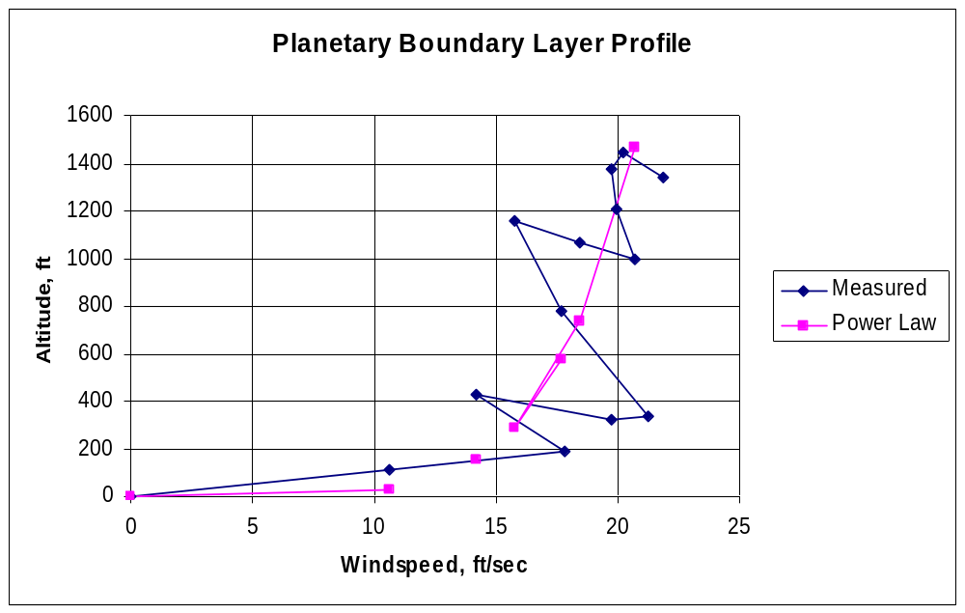

Charley

